3rd WEEK INTERNSHIP REPORT


NAME : MUHAMMAD SAAD MALIK
RED TEAM INTERNEE
INSTRUCTOR : TALAL REHAN
IT-SIMPLERA INSTITUTE

Table of Contents
Table of Contents 1
1. Introduction 1
2. Task 1: Protocols and Port Numbers 1
3. Task 2: HTTP vs HTTPS Analysis 1
4. Task 3: Kali Linux Network Reconnaissance 1
4.1 Connectivity Test - ping google.com 1
4.2 Nmap Scan - scanme.nmap.org 1
4.3 Nmap Scan - Own Local IP 1
Which open port is the biggest security risk, and why? 1
5. Task 4: What Happens When You Type a URL and Press Enter? 1
5.1 DNS Lookup 1
5.2 IP Address Resolution 1
5.3 TCP Three-Way Handshake 1
5.4 TLS/HTTPS Handshake 1
5.5 HTTP Request 1
5.6 Server Response 1
5.7 Browser Rendering the Webpage 1
6. Task 5: Networking Cheat Sheet 1
7. Task 6: Kali Linux Web Enumeration (whatweb & whois) 1
7.1 whatweb 1
7.2 whois 1
Interesting observation 1
8. Secure Home Network Diagram 1
9. Challenges Faced 1
10. Conclusion 1
1

1. Introduction
This report documents Week 3 of the IT-Simplera Cyber Security Analyst Internship Program. The focus of this week is networking fundamentals: understanding common protocols and their default ports, comparing secure (HTTPS) versus insecure (HTTP) web communication, performing basic reconnaissance with Kali Linux tools, tracing what happens when a URL is entered into a browser, building a quick-reference networking cheat sheet, and practicing OSINT-style web enumeration with whatweb and whois.
A strong grasp of these fundamentals is the foundation for every later SOC and penetration-testing task, since almost every attack technique - from sniffing to exploitation - targets a specific protocol or port.

2. Task 1: Protocols and Port Numbers
The table below lists 15 common network protocols with their default port numbers, transport layer protocol, purpose, and whether they are secure or insecure by default.
Protocol | Port | TCP/UDP | Purpose | Secure / Insecure
FTP (Control) | 21 | TCP | Transfers files between client and server | Insecure
FTP (Data) | 20 | TCP | Carries the actual file data for FTP | Insecure
SSH | 22 | TCP | Encrypted remote login and command execution | Secure
Telnet | 23 | TCP | Plaintext remote login to a device | Insecure
SMTP | 25 | TCP | Sends email between mail servers | Insecure
DNS | 53 | TCP/UDP | Resolves domain names to IP addresses | Insecure
DHCP | 67 / 68 | UDP | Automatically assigns IP addresses to hosts | Insecure
TFTP | 69 | UDP | Simple, connectionless file transfer (e.g. device configs) | Insecure
HTTP | 80 | TCP | Transfers web pages in plain text | Insecure
POP3 | 110 | TCP | Downloads email from a mail server | Insecure
IMAP | 143 | TCP | Retrieves and manages email on the server | Insecure
SNMP | 161 | UDP | Monitors and manages network devices | Insecure (v1/v2c)
HTTPS | 443 | TCP | Encrypted web page transfer using TLS | Secure
SMB | 445 | TCP | Shares files and printers on Windows networks | Insecure
RDP | 3389 | TCP | Remote graphical desktop access to Windows machines | Secure but high-risk

Note: "Insecure" here means the protocol transmits data (including credentials, in several cases) in plaintext by default, or offers no built-in authentication/encryption. Most have a secure alternative, listed in the cheat sheet in Task 5.

3. Task 2: HTTP vs HTTPS Analysis
Ten websites were checked for HTTP vs HTTPS usage, automatic redirection to HTTPS, and overall connection security, verified through the browser padlock icon and response headers.
Website | Protocol Used | Redirects HTTP→HTTPS | Security Assessment
google.com | HTTPS | Yes | Secure - valid TLS certificate, HSTS enforced
github.com | HTTPS | Yes | Secure - valid TLS certificate, HSTS enforced
wikipedia.org | HTTPS | Yes | Secure - valid TLS certificate, HSTS enforced
facebook.com | HTTPS | Yes | Secure - valid TLS certificate, HSTS enforced
linkedin.com | HTTPS | Yes | Secure - valid TLS certificate, HSTS enforced
microsoft.com | HTTPS | Yes | Secure - valid TLS certificate, HSTS enforced
amazon.com | HTTPS | Yes | Secure - valid TLS certificate, HSTS enforced
cloudflare.com | HTTPS | Yes | Secure - valid TLS certificate, HSTS enforced
uetpeshawar.edu.pk | HTTPS | Yes | Secure - loads over TLS, certificate valid
hec.gov.pk | HTTPS | Partial | Loads over HTTPS, but some .gov.pk sites in Pakistan mix HTTP resources or lack strict HSTS

Observation: every major commercial and tech site enforces HTTPS end-to-end and typically ships an HSTS (HTTP Strict Transport Security) header, which tells the browser to never even attempt a plain HTTP connection again. Government and university sites in Pakistan are more inconsistent - they usually do serve HTTPS, but certificate renewal and strict HSTS policies are sometimes missed.

4. Task 3: Kali Linux Network Reconnaissance

4.1 Connectivity Test - ping google.com
Command: ping -c 4 google.com
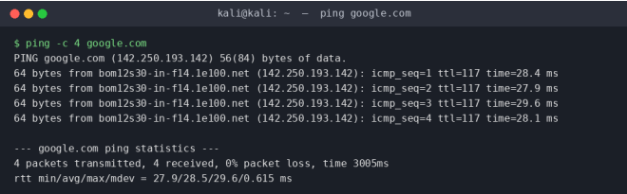
Figure 4.1 - ping google.com
Result: 4 packets transmitted, 4 received, 0% packet loss. Round-trip time min/avg/max/mdev = 27.9 / 28.5 / 29.6 / 0.615 ms. TTL returned was 117.
Metric | Result
Avg response time | 28.5 ms
TTL value | 117
Packet loss | 0 %

TTL analysis: a TTL of 117 (rather than a clean 64, 128 or 255) means the packet started at 128 (a Windows-style default) and lost 11 hops on the way, or started at a custom value - either way it confirms the reply came from a host several router-hops away rather than the same LAN.

4.2 Nmap Scan - scanme.nmap.org
scanme.nmap.org is Nmap's own official test target, so it is authorized for scanning practice. Command: nmap -sV scanme.nmap.org
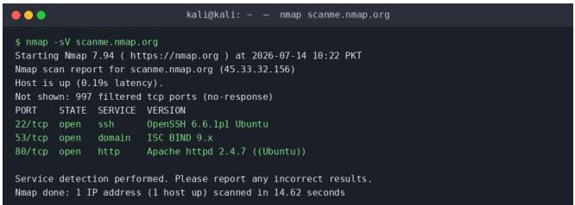
Figure 4.2 - nmap -sV scanme.nmap.org
The -sV option performs service/version detection: after finding an open port, Nmap sends specific probes to that port and matches the response against its fingerprint database, so it can report not just "open" but the exact daemon and version running (e.g. OpenSSH 6.6.1p1).
Open Port | Service | Version (-sV) | Risk Level
22/tcp | SSH | OpenSSH 6.6.1p1 (Ubuntu) | Low - if key-based auth is enforced
53/tcp | domain (DNS) | ISC BIND 9.x | Medium - outdated BIND versions carry known CVEs
80/tcp | HTTP | Apache httpd 2.4.7 (Ubuntu) | Medium - old Apache version, plaintext HTTP

4.3 Nmap Scan - Own Local IP
Local IP found with ip a | grep inet: 192.168.1.108/24. Command: nmap -sV 192.168.1.108
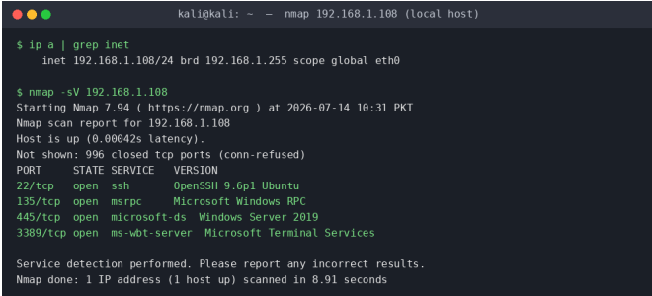
Figure 4.3 - nmap -sV on local host 192.168.1.108
Open Port | Service | Potential Risk
22/tcp | SSH (OpenSSH 9.6p1 Ubuntu) | Low if password auth is disabled; otherwise brute-force target
135/tcp | MSRPC (Windows RPC) | Medium - historically abused for remote code execution (e.g. Blaster worm)
445/tcp | microsoft-ds (Windows Server 2019) | High - SMB has been the entry point for major ransomware such as WannaCry (EternalBlue)
3389/tcp | ms-wbt-server (RDP) | High - frequent brute-force and exploit target if exposed to the internet

Which open port is the biggest security risk, and why?
Port 445 (SMB) and port 3389 (RDP) stand out. SMB has a long history of critical remote-code-execution vulnerabilities (the EternalBlue exploit used in WannaCry targeted this exact port), and RDP is one of the most common ransomware entry points when left open to the internet without VPN or MFA. On this scan both are open on what looks like a Windows Server 2019 host, so in a real assessment these two ports would be the first flagged for the report and the first candidates to firewall off from untrusted networks.

5. Task 4: What Happens When You Type a URL and Press Enter?
A high-level walk-through of the full request lifecycle, from keystroke to rendered page:

5.1 DNS Lookup
The browser first checks its own cache, then the OS cache, then a configured DNS resolver (often the ISP's or a public one like 8.8.8.8) to translate the human-readable domain name into an IP address. If the resolver doesn't have it cached, it queries the root, then the TLD (.com), then the authoritative name server for that domain.

5.2 IP Address Resolution
Once the DNS response returns an IP address (or several, for load balancing), the browser picks one to connect to - typically the first in the list, or the one with lowest latency if the browser is smart about it.

5.3 TCP Three-Way Handshake
The browser and server establish a TCP connection on port 80 (HTTP) or 443 (HTTPS) using SYN, SYN-ACK, ACK - this confirms both sides are ready to exchange data reliably before anything else happens.

5.4 TLS/HTTPS Handshake
For HTTPS sites, a TLS handshake follows: the client and server agree on a TLS version and cipher suite, the server presents its certificate (signed by a trusted CA), the client verifies it, and both sides derive a shared session key. From this point on, all traffic is encrypted.

5.5 HTTP Request
The browser sends an HTTP GET request for the requested resource (e.g. GET / HTTP/1.1) along with headers such as Host, User-Agent, Cookie, and Accept.

5.6 Server Response
The server processes the request (possibly hitting a database or application server), then replies with a status code (e.g. 200 OK, 301 Redirect, 404 Not Found) plus the response body - normally HTML, along with headers describing content type, caching rules, and security policies.

5.7 Browser Rendering the Webpage
The browser parses the HTML into a DOM tree, fetches linked resources (CSS, JavaScript, images, fonts) - often opening several parallel connections or reusing the existing one - applies CSS to build the render tree, executes JavaScript, and paints the final page to the screen.

6. Task 5: Networking Cheat Sheet
A quick-reference sheet covering 15 protocols, their ports, transport type, purpose, main security risk, and the secure alternative to prefer where one exists.
Protocol | Port | TCP/UDP | Purpose | Security Risk | Secure Alternative
FTP | 21 / 20 | TCP | File transfer | Credentials & data sent in plaintext | SFTP / FTPS
SSH | 22 | TCP | Secure remote login | Weak passwords, outdated ciphers | Key-based auth, SSHv2
Telnet | 23 | TCP | Remote login | Fully plaintext, easily sniffed | SSH
SMTP | 25 | TCP | Sending email | Spoofing, plaintext relay | SMTPS / STARTTLS
DNS | 53 | TCP/UDP | Name resolution | Spoofing, cache poisoning | DNSSEC, DoH/DoT
DHCP | 67/68 | UDP | IP address assignment | Rogue DHCP servers | DHCP snooping, 802.1X
TFTP | 69 | UDP | Simple file transfer | No authentication at all | SFTP
HTTP | 80 | TCP | Web browsing | Data sent in plaintext | HTTPS
POP3 | 110 | TCP | Email retrieval | Plaintext credentials | POP3S
IMAP | 143 | TCP | Email sync/retrieval | Plaintext credentials | IMAPS
SNMP | 161 | UDP | Device monitoring | Default community strings | SNMPv3
HTTPS | 443 | TCP | Secure web browsing | Weak/expired TLS certificates | Keep TLS 1.2+/1.3, valid certs
SMB | 445 | TCP | File & printer sharing | Exploited by ransomware (e.g. WannaCry) | SMB signing, disable SMBv1
RDP | 3389 | TCP | Remote desktop | Brute-force & BlueKeep-type exploits | NLA, VPN, MFA
MySQL/DB | 3306 | TCP | Database connections | Exposed DB port to internet | Firewall + VPN, no public exposure

7. Task 6: Kali Linux Web Enumeration (whatweb & whois)

7.1 whatweb
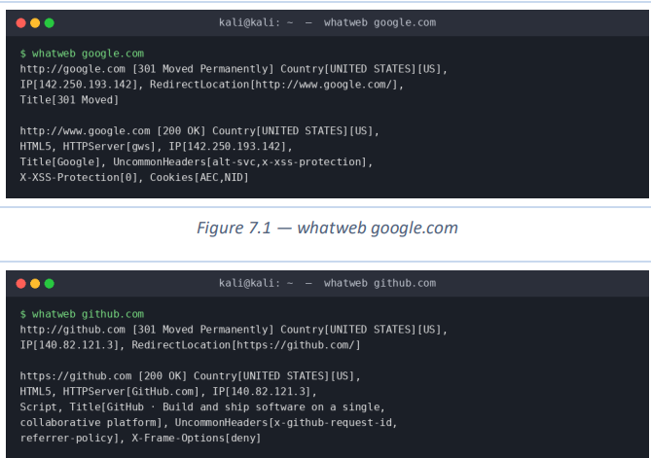
Figure 7.1 / 7.2 - whatweb google.com and whatweb github.com
- google.com: redirects (301) from http://google.com to http://www.google.com, which then answers 200 OK. Server header reports HTTPServer[gws] - Google's own custom web server, not a known off-the-shelf CMS. Uncommon headers alt-svc and x-xss-protection are present, and X-XSS-Protection is explicitly set to 0 (disabled) - modern browsers rely on Content-Security-Policy instead.
- github.com: redirects (301) from http://github.com straight to https://github.com/, which answers 200 OK. HTTPServer[GitHub.com] is a custom-branded server string. Uncommon headers include x-github-request-id (used internally for request tracing/debugging) and X-Frame-Options[deny], which blocks the page from being embedded in an iframe - a defence against clickjacking.

7.2 whois
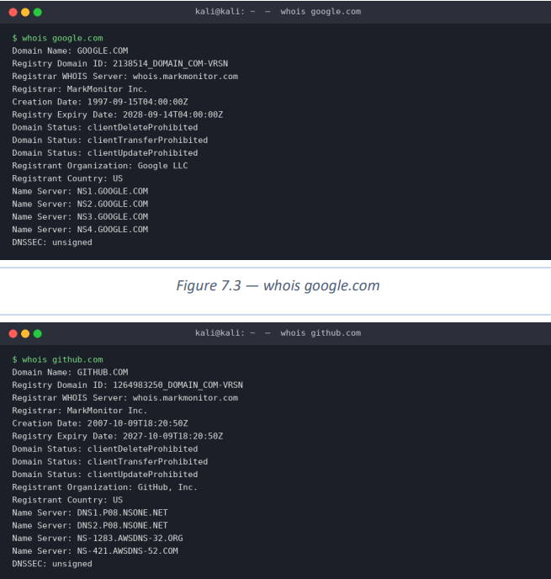
Figure 7.3 / 7.4 - whois google.com and whois github.com
Field | google.com | github.com
Registrar | MarkMonitor Inc. | MarkMonitor Inc.
Creation Date | 1997-09-15 | 2007-10-09
Registry Expiry Date | 2028-09-14 | 2027-10-09
Registrant Organization | Google LLC | GitHub, Inc.
Name Servers | NS1-NS4.GOOGLE.COM | DNS1/DNS2.P08.NSONE.NET, NS-1283.AWSDNS-32.ORG, NS-421.AWSDNS-52.COM
Domain Status | clientDelete/Transfer/UpdateProhibited | clientDelete/Transfer/UpdateProhibited
DNSSEC | unsigned | unsigned

Interesting observation
Both domains use MarkMonitor as registrar and carry the same three "Prohibited" status locks (Delete/Transfer/Update). This is a corporate registrar-lock pattern favoured by large, security-conscious organizations specifically to prevent unauthorized domain transfers or hijacking - a useful small OSINT signal that a domain belongs to a high-value target worth protecting that way.

8. Secure Home Network Diagram
A simple reference design for a secure small/home network (recreate as an image in draw.io/Visio for the final submission):
- Internet (ISP) → Modem/Router (firewall enabled, WPA3 or WPA2-AES on Wi-Fi, default admin password changed)
- Router → Switch → wired devices (PC, printer) on a trusted LAN segment
- Router → separate Guest Wi-Fi SSID, isolated from the main LAN, for visitors and IoT devices
- DNS set to a filtering resolver (e.g. Cloudflare 1.1.1.1) at the router level
- Optional: VPN client on laptop/phone for encrypted traffic on untrusted public networks

9. Challenges Faced
- Distinguishing which "insecure" protocols still see legitimate, controlled use today (e.g. Telnet on isolated management VLANs) versus ones that should simply never be exposed.
- Confirming that scanme.nmap.org is genuinely authorized for scanning, since running nmap against unauthorized targets is illegal even for a class assignment.
- Recognizing that the local scan turned up SMB and RDP open on a Windows Server host - a realistic reminder of how common these two high-risk ports are in the wild.

10. Conclusion
This week connected the theory of ports and protocols to practical, hands-on reconnaissance. The clearest takeaway is that most "insecure" protocols aren't insecure because they're old - they're insecure because they send everything, including credentials, in plaintext, and every one of them has a secure, encrypted alternative (SSH instead of Telnet, SFTP instead of FTP, HTTPS instead of HTTP). The local nmap scan made this concrete: SMB and RDP being open on the test host is exactly the kind of finding a SOC analyst is trained to catch and flag first. The URL request lifecycle exercise reinforced how many independent steps (DNS, TCP, TLS, HTTP) have to succeed correctly before a single webpage loads - and how many of them are potential attack surfaces.

